Tutorial 2

Exercise 1:

Table 1:

X | 2 | 2 | 3 | 3 | 4 | 4 | 5 | 5 | 6 | 6
Y | 0 | 4 | 1 | 5 | 2 | 6 | 3 | 7 | 4 | 8

Scatter plot:
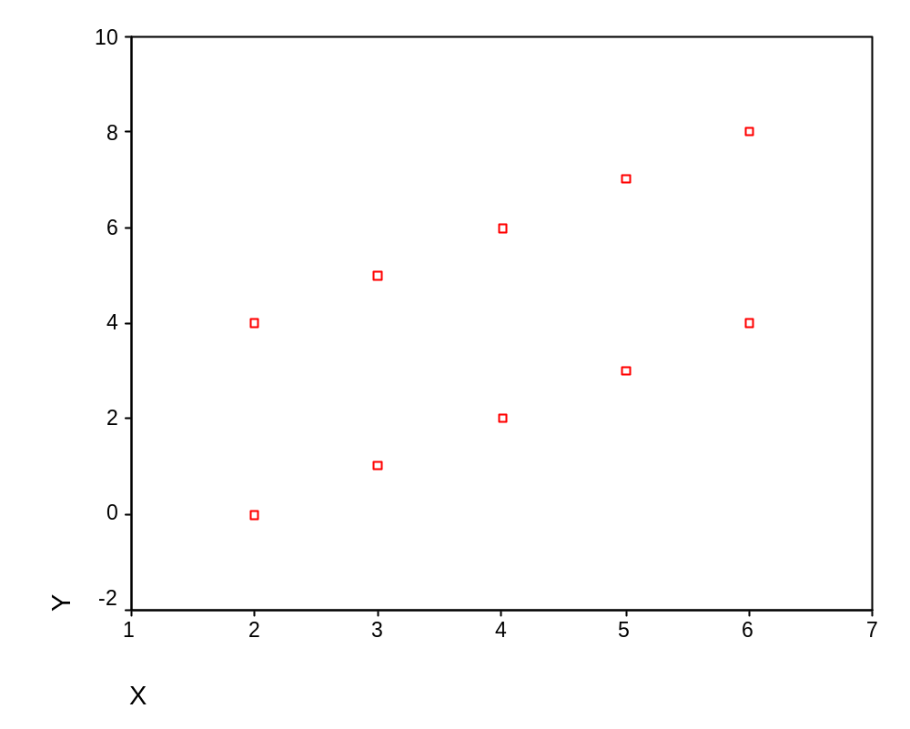
Mean:
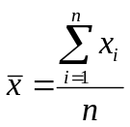

Thus

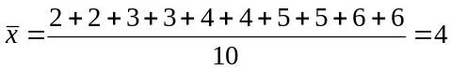

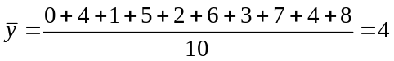

Variances:
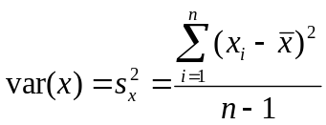
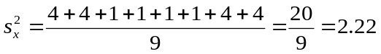
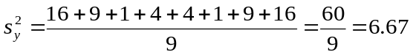
Standard deviations:

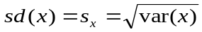

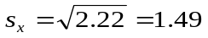

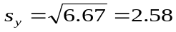

Covariances:
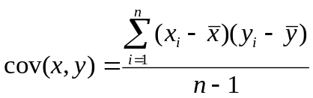

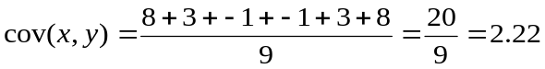

Correlations:

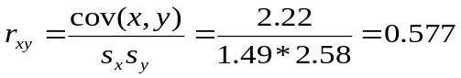
Exercise 2a

Linear transformations
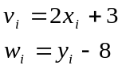

Linear combinations
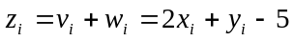

Means

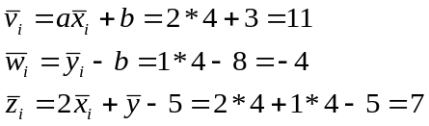

Variances

Calculate using table:

Table var(v) = cov (v,v) 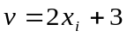
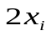
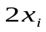

Table var(w) 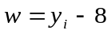
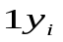

Table var(z) 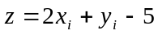
 | 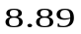 | 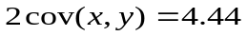
 | 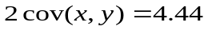 | 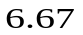

Standard deviations

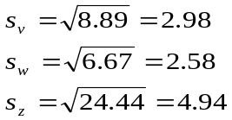

Exercise 2b

Covariances

cov(v,w)

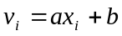
and
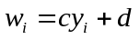

Calculate with help of tables.

Table cov(v,w)
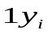
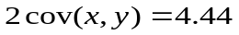

Table cov(v,z)
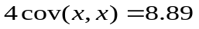

Table cov(w,z)
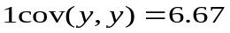

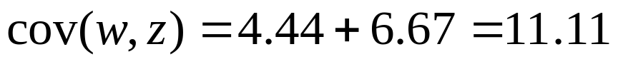

Correlations

Correlation between v end w

If ac >0 , than r_{vw} = r_{xy}
If ac<0 , than r_{vw} = -r_{xy}

With linear transformations correlation remains the same in absolute values.

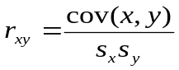

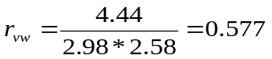

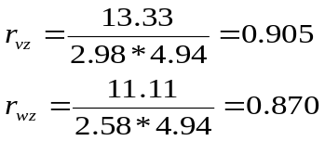
Total

 | X | Y | V | W | Z
Means | 4 | 4 | 11 | -4 | 7
Variances | 2.22 | 6.67 | 8.89 | 6.67 | 24.44

Covariance matrix
Covariance | V | W | Z
V | 8.89
W | 4.44 | 6.67
Z | 13.33 | 11.11 | 24.44

Correlation matrix
Correlation | V | W | Z
V | 1
W | 0.577 | 1
Z | 0.905 | 0.870 | 1

Exercise 3a

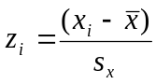

Table 1:
X | 2 | 2 | 3 | 3 | 4 | 4 | 5 | 5 | 6 | 6
Y | 0 | 4 | 1 | 5 | 2 | 6 | 3 | 7 | 4 | 8

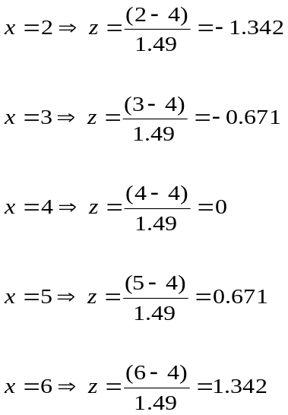
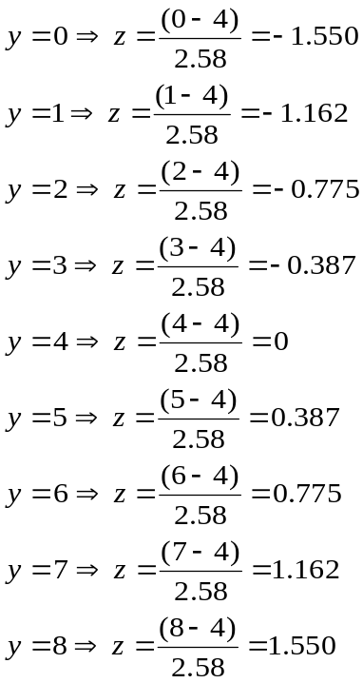
Exercise 3b

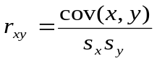

For z-scores standard deviations are always equal to 1, thus for z-scores:

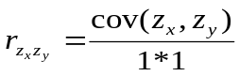

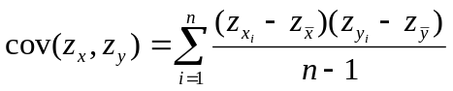

For z-scores means are always 0, thus for z-scores:

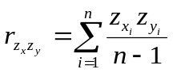

Table 1:

 | A | B | C | D | E | F | G | H | I | J
X | 2 | 2 | 3 | 3 | 4 | 4 | 5 | 5 | 6 | 6
Y | 0 | 4 | 1 | 5 | 2 | 6 | 3 | 7 | 4 | 8

Calculate with z-scores from 3a.

A: -1.342 * -1.549 = 2.079
B: 0 = 0
C: -0.671 * -1.162 = 0.780
D: -0.671 * 0.387 = -0.260
E: 0 = 0
F: 0 = 0
G: 0.671 * -0.387 = -0.260
H: 0.671 * 1.162 = 0.780
I: 0 = 0
J: 1.342 * 1.549 = 2.079
5.198 +

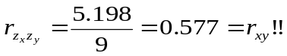
Exercise 4

- 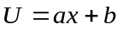 (when a > 0)
- 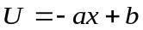 (when a > 0)
- 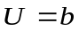(when a = 0)
- 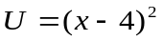

Examples:

- U = 2x+1

X | 2 | 2 | 3 | 3 | 4 | 4 | 5 | 5 | 6 | 6
U | 5 | 5 | 7 | 7 | 9 | 9 | 11 | 11 | 13 | 13

- U = -2x+1

X | 2 | 2 | 3 | 3 | 4 | 4 | 5 | 5 | 6 | 6
U | -3 | -3 | -5 | -5 | -7 | -7 | -9 | -9 | -11 | -11

- U = 9 + E

X | 2 | 2 | 3 | 3 | 4 | 4 | 5 | 5 | 6 | 6
U | 8 | 10 | 8 | 10 | 10 | 8 | 10 | 8 | 8 | 10

- U = 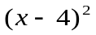

X | 2 | 2 | 3 | 3 | 4 | 4 | 5 | 5 | 6 | 6
U | 4 | 4 | 1 | 1 | 0 | 0 | 1 | 1 | 4 | 4

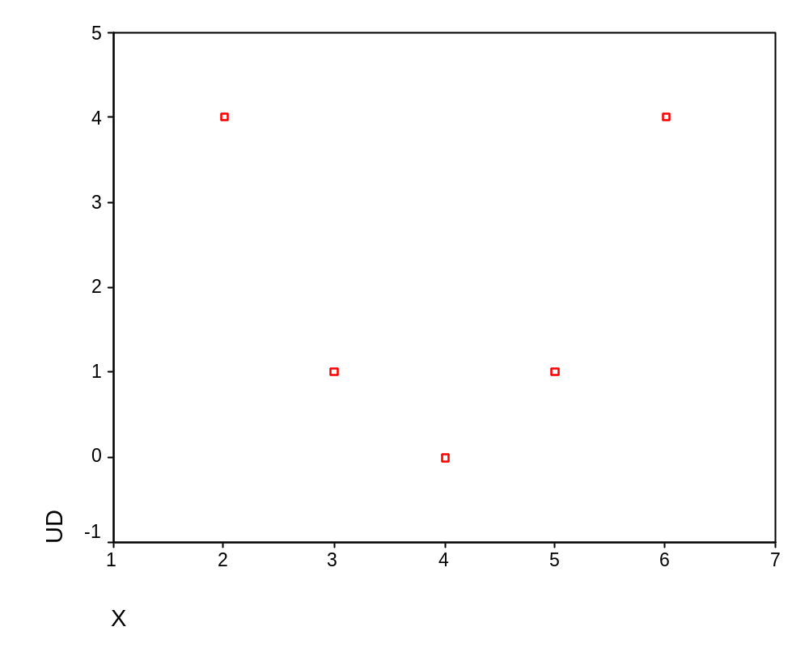
Exercise 5

Null hypothesis: correlation between X and Y in population is equal to zero:

H₀: ρ_{xy}= 0
H_{a}: ρ_{xy}≠ 0

Test statistic:

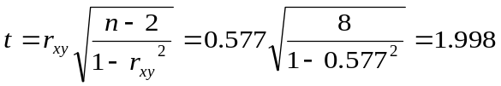
Two-tailed t-test:
t_{cv}(df = n-2) = t_{cv}(8)_{α=0.05}= ± 2.306

Conclusion: H₀ not rejected.

Seee Hinkle, Wiersma and Jurs Chapter.10 pp. 235-238

Spss ouput
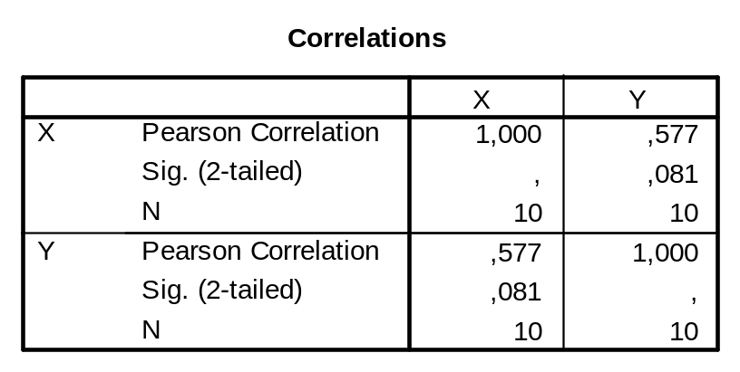
Exercise 6

Proportion of explained (predicted) variance = 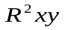

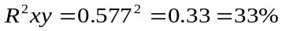

Exercise 7

a)
 | A | B | C | D | E | F | G | H | I | J | K
X | 2 | 2 | 3 | 3 | 4 | 4 | 5 | 5 | 6 | 6 | 10000
Y | 0 | 4 | 1 | 5 | 2 | 6 | 3 | 7 | 4 | 8 | -10000

R is -1.00

b)
 | A | B | C | D | E | F | G | H | I | J | K
X | 2 | 2 | 3 | 3 | 4 | 4 | 5 | 5 | 6 | 6 | 10000
Y | 0 | 4 | 1 | 5 | 2 | 6 | 3 | 7 | 4 | 8 | 10000

R is 1.00
Exercise 8

Table 1 when x>3

X | 4 | 4 | 5 | 5 | 6 | 6
Y | 2 | 6 | 3 | 7 | 4 | 8

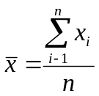

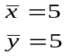
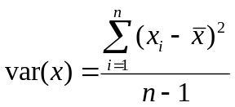

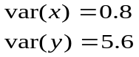

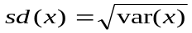

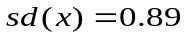
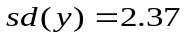

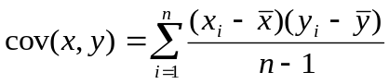

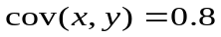

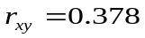
Exercise 9a.

X2 = X+10
Y2 = Y-10

Table:

X | 2 | 2 | 3 | 3 | 4 | 4 | 5 | 5 | 6 | 6
Y | 0 | 4 | 1 | 5 | 2 | 6 | 3 | 7 | 4 | 8
X2 | 12 | 12 | 13 | 13 | 14 | 14 | 15 | 15 | 16 | 16
Y2 | -10 | -6 | -9 | -5 | -8 | -4 | -7 | -3 | -6 | -2
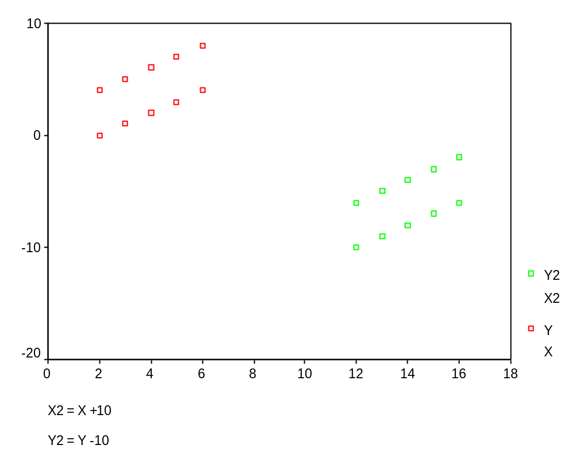
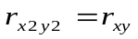
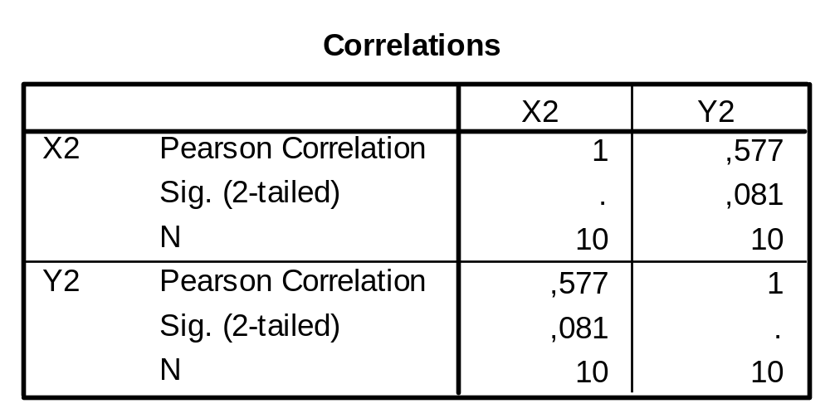

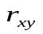in group I +II is negative

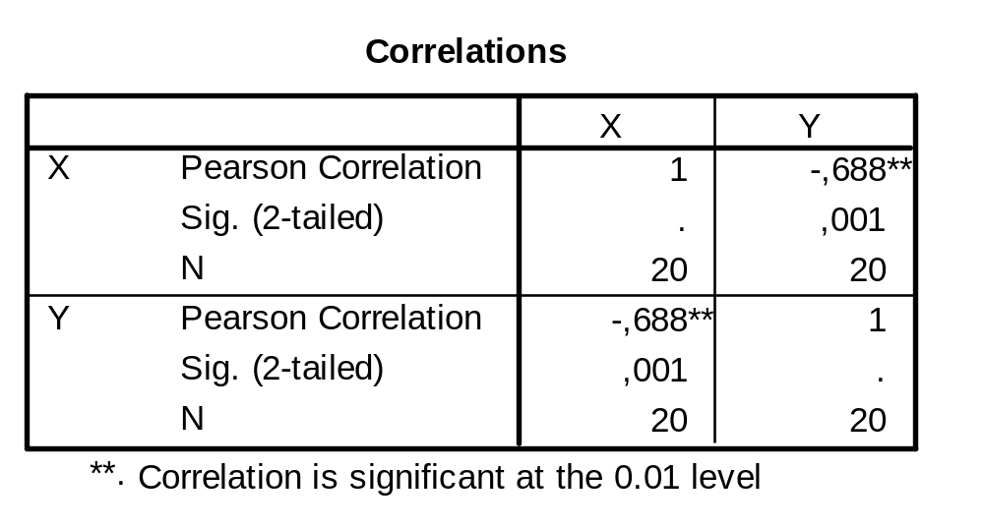

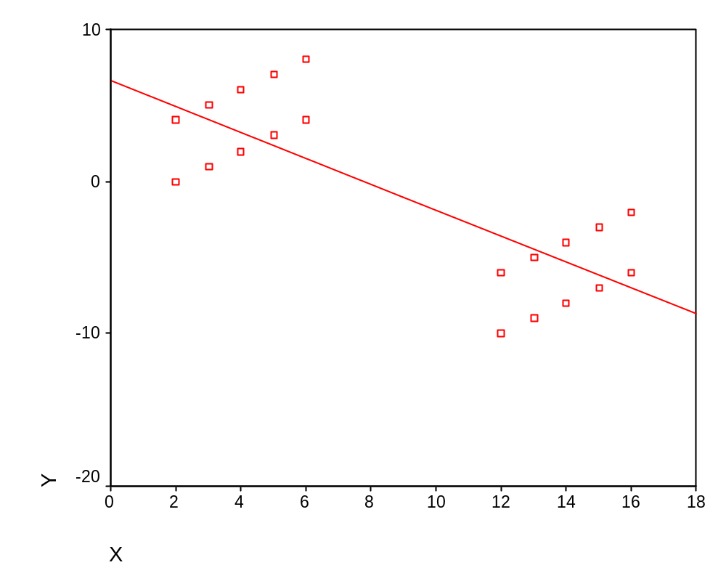

Exercise 9b.

X2 = X
Y2 = -Y

Table:

X | 2 | 2 | 3 | 3 | 4 | 4 | 5 | 5 | 6 | 6
Y | 0 | 4 | 1 | 5 | 2 | 6 | 3 | 7 | 4 | 8
X2 | 2 | 2 | 3 | 3 | 4 | 4 | 5 | 5 | 6 | 6
Y2 | -0 | -4 | -1 | -5 | -2 | -6 | -3 | -7 | -4 | -8

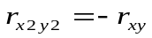
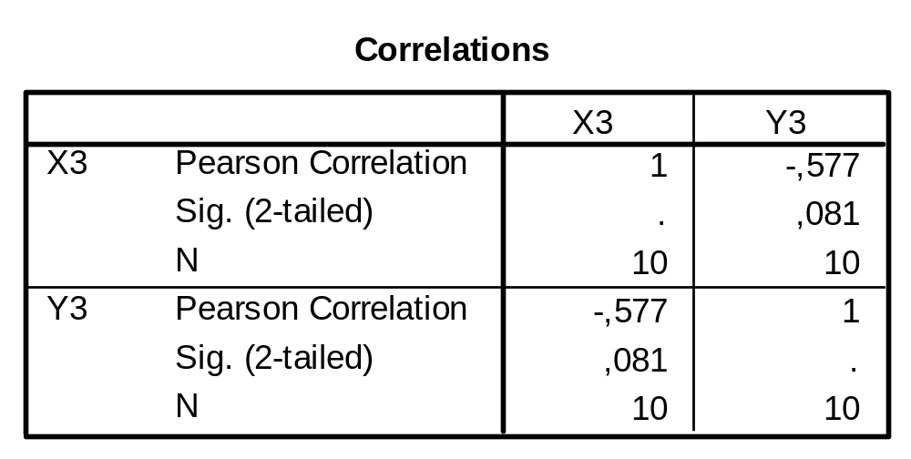

in group I +II is 0

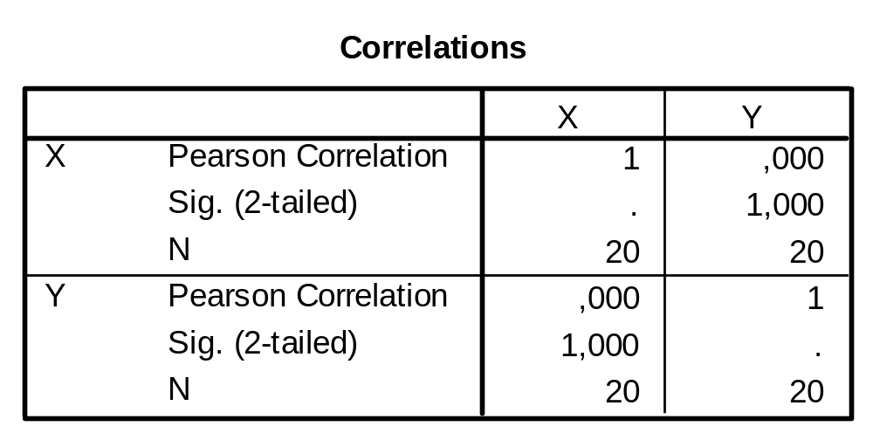

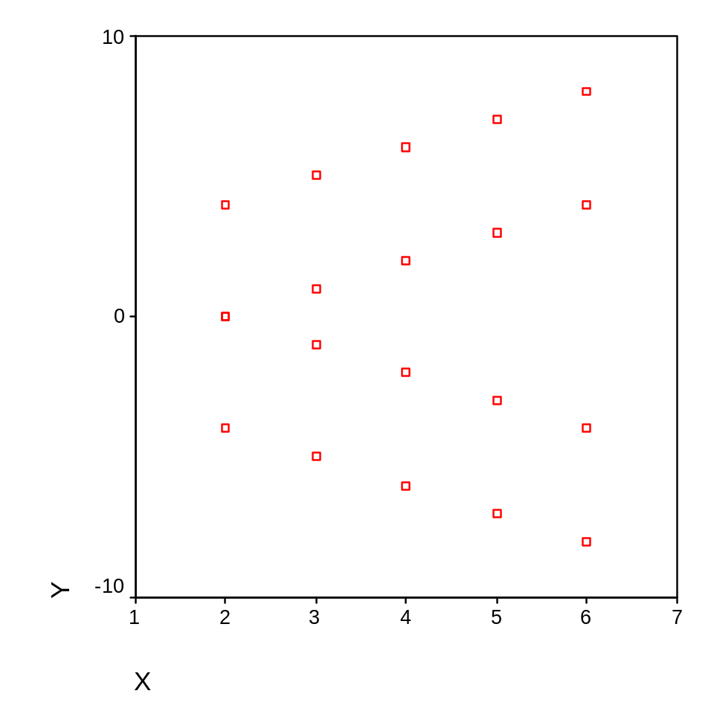

Exercise 10

 | X=0 | X=1 | Total
Y=0 | A | B | 12
Y=1 | C | D | 28
Total | 36 | 4 | 40

Correlation r for 2 dichotomous variables is equal to Φ:

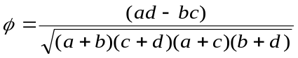

Note:

with minimum correlation, we mean:

lower limit (largest neg. value)
lower limit as ad-bc takes maximal negative value.

and with maximum correlation:

higher limit (highest pos. value)
higher limit as ad-bc takes maximum positive value
Lower limit:
 | X=0 | X=1 | Total
Y=0 | 8 (a) | 4 (b) | 12
Y=1 | 28 (c) | 0 (d) | 28
Total | 36 | 4 | 40

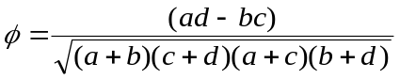

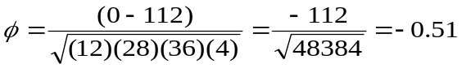

Higher limit:
 | X=0 | X=1 | Total
Y=0 | 12 (a) | 0 (b) | 12
Y=1 | 24 (c) | 4 (d) | 28
Total | 36 | 4 | 40

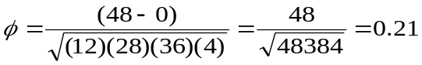

In this way we can see that the correlation lays between: -0.51 ≤ Φ ≤ 0.21

